**Software Design Document**

**SOFTWARE REQUIREMENTS: -**

**Anaconda**



Anaconda is a open-source distribution of the Python and R programming languages for scientific computing, that aims to simplify package management and deployment. The distribution includes data-science packages suitable for Windows, Linux, and macOS.

**Visual Studio Code**

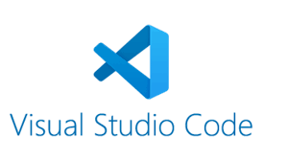

Visual Studio Code is a free source-code editor made by Microsoft for Windows, Linux and macOS. Features include support for debugging, syntax highlighting, intelligent code completion, snippets, code refactoring, and embedded Git.

**GUI for Configurator**

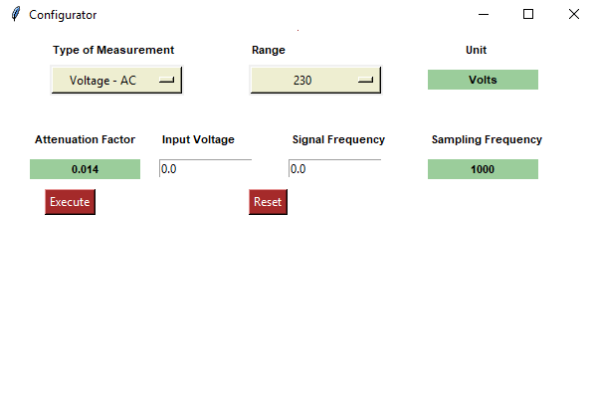

**Input Signal**

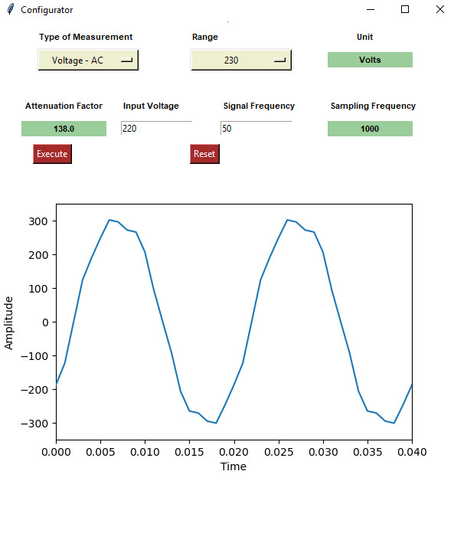

**GUI for Configurator**

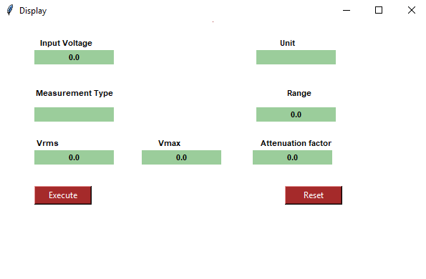

**Input Signal**

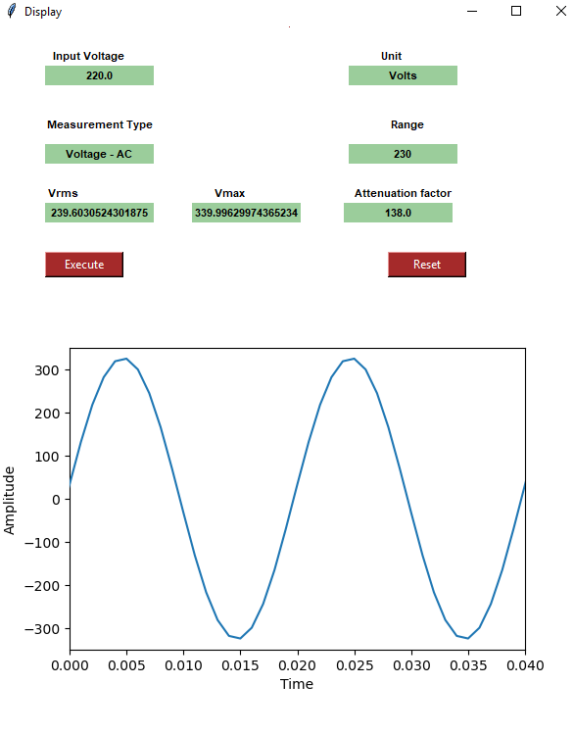

**Libraries used :**

1. **Tkinter**

Tkinter is the most commonly used method for developing GUI. Python with Tkinter is the fastest and easiest way to create GUI applications.

Tkinter widgets used for developing GUI:

* Entry widget
* Label
* Canvas
* Option button
* Entry

1. **Matplotlib**

* **Matplotlib** is a [plotting](https://en.wikipedia.org/wiki/Plotter) [library](https://en.wikipedia.org/wiki/Library_(computer_science)) for the [Python](https://en.wikipedia.org/wiki/Python_(programming_language)) programming language and its numerical mathematics extension [NumPy](https://en.wikipedia.org/wiki/NumPy" \o "NumPy).
* It is mainly used for plotting graph

1. **Animation**

* Animations make even more sense when depicting time series data
* Matplotlib’s animation base class deals with the animation part.
* It provides a framework around which the animation functionality is built.
* [FuncAnimation](https://matplotlib.org/api/_as_gen/matplotlib.animation.FuncAnimation.html" \l "matplotlib.animation.FuncAnimation" \t "_blank) is the main object that makes an animation by repeatedly calling a function func.